

Topic test 2
Name: __________________________________

Chapter 1: Equations and polynomials

• Time allowed: 45 minutes
• CAS calculators may be used.
• Part A: 5 multiple-choice questions (5 marks)
• Part B: 6 short answer questions (29 marks)
• Part C: 3 analysis questions (26 marks)
Part A
5 multiple-choice questions
1 mark each: 5 marks
Circle the correct answer.
1 The solution of 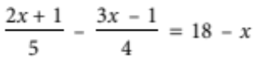 is:
A –4.5
B –1.5
C 27
D 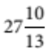
E 13

[1 mark]
2 Make a the subject of the formula v2 = n2(a2 – x2).
A 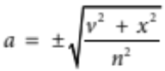
B 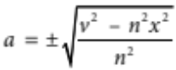
C 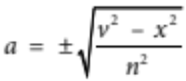
D 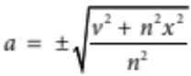
E 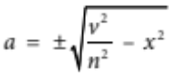
[1 mark]
3 Given that y is inversely proportional to the square root of x, and that y = 24 when x = 36, find the value of x when y = 96.
A
B
C
D
E 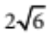

[1 mark]
4 For the polynomial P(x) = 3x4 + 2x3 – x – 2, the degree, the leading coefficient, the constant and P(–1) are respectively:
A 3, 4, –2, 0
B 4, 3, 2, 0
C 4, 3, 2, –2
D 3, 4, –2, –2
E 4, 3, –2, 0

[1 mark]
5 Factorise x3 + 6x2 + 5x – 12.
A (x – 1)(x – 3)(x + 4)
B (x – 1)(x + 3)(x + 4)
C (x – 1)(x – 3)(x – 4)
D (x + 1)(x – 3)(x + 4)
E (x + 1)(x + 3)(x – 4)

[1 mark]

Part B
6 short answer questions
29 marks
Show your working where appropriate.
1 Solve the following equations.
a 3 + 2(m – 4) = 4m – (3m – 2)

b 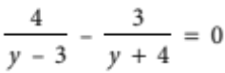(y ≠ 3, –4)

[5 marks]
2 Solve the following equations.
a (3x – 2)(x + 9) = 0

b x2 + 4x – 8 = 0 (by completing the square)

c 3x2 – 5x – 12 = 0 (by factorisation)

d x2 – 7x + 4 = 0 (using the quadratic formula)

[10 marks]

3 Mike had a pen with chickens and rabbits in it. Between them, the animals had 42 heads and 142 feet.
Write equations and solve them to find out how many chickens and how many rabbits there were in the pen.

[4 marks]
4 The number of litres of milk produced by a dairy farmer’s herd is directly proportional to the
number of cows milked. The farmer gets 4980 litres of milk from milking 120 cows.
How many cows would he need to produce 8715 litres of milk?

[3 marks]
5 For the function P(x) = 2x3 + 4x2 – x + 1, find the remainder when P(x) ÷ (x – 4).

[2 marks]
6 Divide the polynomial P(x) = 2x3 + 4x2 – x + 1 by x – 3 and hence write P(x) in the form
P(x) = (x – 3)Q(x) + R.

[5 marks]
Part C
3 analysis questions
26 marks
Show your working where appropriate.
1 A Wilderness Trekking tour operator offers complete packages to the Tasmanian World Heritage areas from Launceston. The cycling tours may be from 3 to 12 days in length. They cost $780 for the 3-day tour and $180 for each additional day.
a Draw a graph showing the cost of the cycling tours.

b Find a relationship between the number of days and the cost of the tours.

The operator also offers walking treks of any duration from 1 to 20 days with a flat rate of $210 per day.
c Draw a graph of the cost of the walking treks.
d Find a relationship between the number of days and the cost of the treks.

e State the circumstances under which each of the walking or cycling options would be cheaper.

[12 marks]
2 A golden rectangle has sides in the golden ratio x : 1 such that, if a square is cut off, the ratio of the sides of the remaining rectangle is also x : 1.
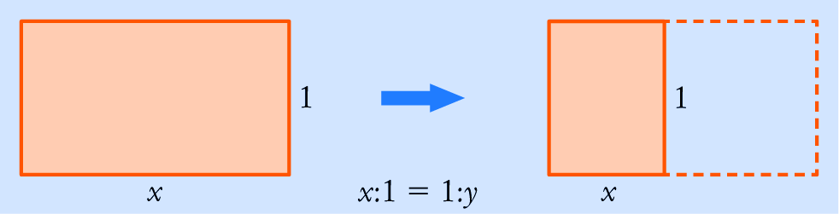
a Show two ways to write the length of y in terms of x.

b Hence write an equation involving only x and rearrange the equation into standard form.

c Solve the equation to find the golden ratio x.

d If one side of a golden rectangle is 5 m, what are the possible lengths of the remaining side?

[7 marks]
3 Solve 2x3 – 12x2 + 10x + 24 = 0

[7 marks]
Total marks: 60
Answers
Part A [1 mark each]
1 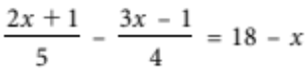
4(2x + 1) – 5(3x – 1) = 20(18 – x)
8x + 4 – 15x + 5 = 360 – 20x
–7x + 9 = 360 – 20x
13x = 351
x = 27
 C [1 mark]
2 v2 = n2(a2 – x2)
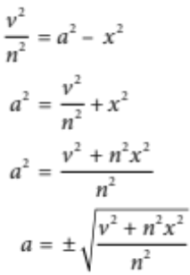
 D [1 mark]
3 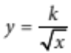
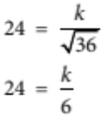
k = 144
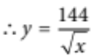
When y = 96
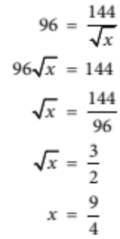
 C [1 mark]

4 Leading term is 3x4, so degree is 4 and leading coefficient is 3. Constant is –2 and
P(–1) = 3(–1)4 + 2(–1)3 – (–1) – 2
= 3  1 + 2  (–1) + 1 – 2
= 3 – 2 + 1 – 2
= 0
 E [1 mark]
5 P(x) = x3 + 6x2 + 5x – 12
P(1) = (1)3 + 6(1)2 + 5(1) – 12
= 0
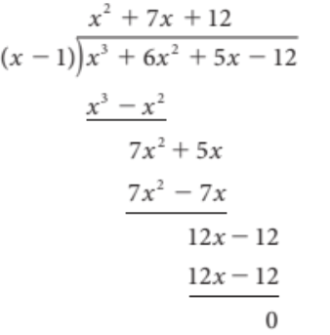
[ (x – 1) is a factor.
 x3 + 6x2 + 5x – 12 = (x – 1)(x2 + 7x + 12)
= (x – 1)(x + 3)(x + 4)
 B [1 mark]

Part B
1 a 3 + 2(m – 4) = 4m – (3m – 2)
3 + 2m – 8 = 4m – 3m + 2 [1 mark]
2m – 5 = m + 2
m = 7 [1 mark]
b 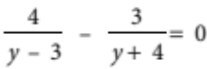
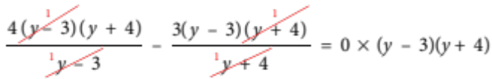
[1 mark]
4(y + 4) – 3(y – 3) = 0
4y + 16 – 3y + 9 = 0 [1 mark]
y + 25 = 0
y = –25 [1 mark]

2 a (3x – 2)(x + 9) = 0
3x – 2 = 0 or x + 9 = 0
3x = 2 or x = –9
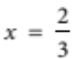 [1 mark]
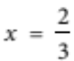 [1 mark]
b x2 + 4x – 8 = 0
x2 + 4x = 8
x2 + 4x + 4 = 8 + 4 [1 mark]
(x + 2)2 = 12 [1 mark]
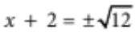
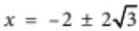
[1 mark]
c 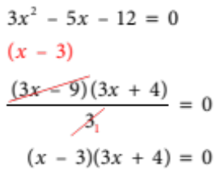 [1 mark]
x – 3 = 0 or 3x + 4 = 0 [2 marks, 1 mark for each solution]
x = 3 or 3x = –4
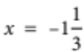.
Solution: 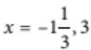
d x2 – 7x + 4 = 0
Use the quadratic formula.
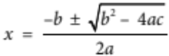
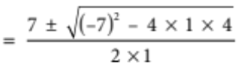
[1 mark]
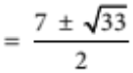
[1 mark]

3 Let the number of chickens be c and the number of rabbits be r.
Then c + r = 42 [1]
and 2c + 4r = 142 [2] [1 mark]
[1] × 2 2c + 2r = 84 [1a]
[2] – [1a] 2r = 58
r = 29 [1 mark]
Substitute r = 29 into [1]. [1 mark]
c + 29 = 42
c = 13 [1 mark]
Solution: There were 13 chickens and 29 rabbits in the pen.
4 m = kc [1 mark]
When m = 4980, c = 120, so
4980 = 120k
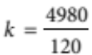
k = 41.5 [1 mark]
 m = 41.5c
When m = 8715, c = ?
8715 = 41.5c
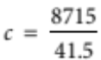
c = 210 [1 mark]
The farmer gets 8715 litres of milk from 210 cows.
5 P(x) = 2x3 + 4x2 – x + 1
P(4) = 2(4)3 + 4(4)2 – (4) + 1 [1 mark]
= 128 + 64 – 4 + 1
Remainder = 189 [1 mark]
6 P(x) = 2x3 + 4x2 – x + 1
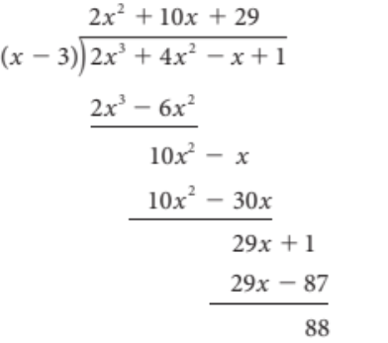 | [1 mark]  [1 mark]  [1 mark]
 2x3 + 4x2 – x + 1 = (x – 3)(2x2 + 10x + 29) + 88 [1 mark]

Part C
1 a 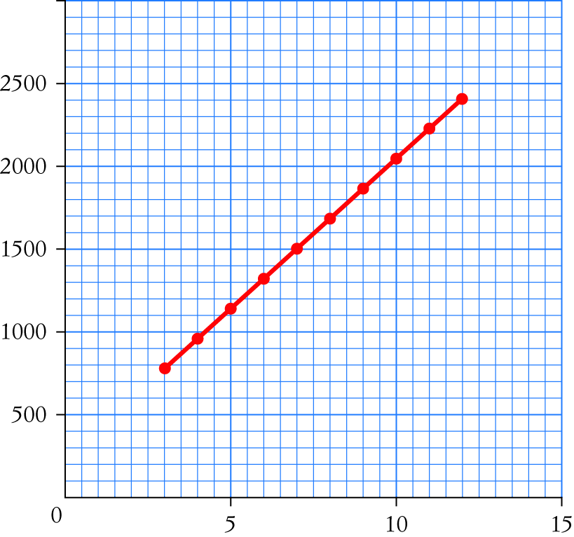
[2 marks for graph. 1 for axes and labelling, 1 for correct linear graph]
Days | 3 | 4 | 5 | 6 | 7 | 8 | 9 | 10 | 11 | 12
Cost | 780 | 960 | 1140 | 1320 | 1500 | 1680 | 1860 | 2040 | 2220 | 2400
[1 mark]
b Cost of 3 days at $180 per day = $540
But 3 days cost $780, i.e. $540 + $240 [1 mark]
 Cost of 3 days = $180 × 3 + $240
Cost of tour = 180d + 240 [1 mark]
c 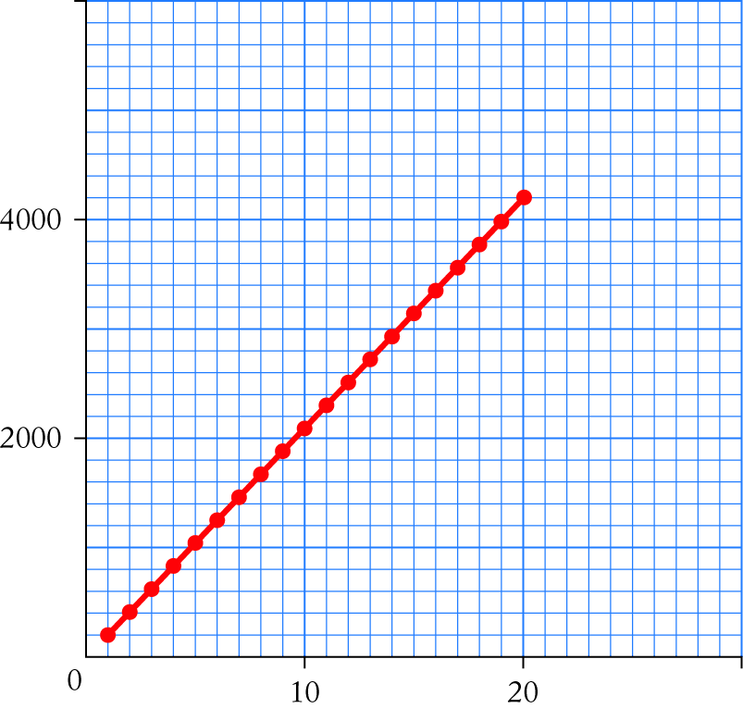
[2 marks for graph. 1 for axes and labelling, 1 for correct linear graph]

Days | 1 | 2 | 3 | 4 | 5 | 6 | 7 | 8 | 9 | 10
Cost | 210 | 420 | 630 | 840 | 1050 | 1260 | 1470 | 1680 | 1890 | 2100
[1 mark]
Days | 11 | 12 | 13 | 14 | 15 | 16 | 17 | 18 | 19 | 20
Cost | 2310 | 2520 | 2730 | 2940 | 3150 | 3360 | 3570 | 3780 | 3990 | 4200
d C = 210d [1 mark]
The cost is $210 per day. That is,
Cost = $210 × number of days [1 mark]
e For walking, treks between 3 and 7 days are cheaper. For cycling, tours between 9 and
12 days are cheaper. For tours of 8 days, they are the same value. [1 mark]
Looking at the two tables, before Day 8, Walking Treks are cheaper. On Day 8, they are the
same price. [1 mark]
2 a A rectangle of length x units and width 1 unit has a square of 1 unit cut off it. So the length
left is x – 1 units. So y = x – 1. [1 mark]
Given the ratio x : 1 = 1 : y then
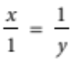
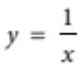
[1 mark]
b Combining the two equations in part a, we get
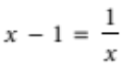
Multiply both sides by x.
x2 – x = 1
x2 – x – 1 = 0 [1 mark]
c Solve x2 – x – 1 = 0 using the quadratic formula.
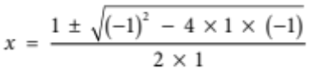
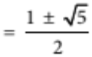 [1 mark]
But x is a length and must be positive, so:
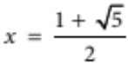
1.618 [1 mark]
d Let x  5 = 1.618
x = 1.618 × 5
x = 8.09 [1 mark]
Let 5  y = 1.618
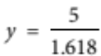
y = 3.09 [1 mark]
3 2x3 – 12x2 + 10x + 24 = 0
2(x3 – 6x2 + 5x + 12) = 0 [1 mark]
P(–1) = (–1)3 – 6(–1)2 + 5(–1) + 12
= 0
 (x + 1) is a factor [1 mark]
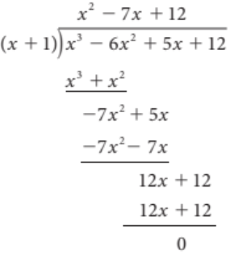
[2 marks for division working out, minus 1 for each mistake]

 2(x + 1)(x2 – 7x + 12) = 0 [1 mark]
2(x + 1)(x – 3)(x – 4) = 0 [1 mark]
x + 1 = 0 or x – 3 = 0 or x – 4 = 0 [1 mark]
x = –1 x = 3 x = 4
Solution: x = –1, 3, 4

